**Moulik Tammana**

**Q3. Explore traceroute/ tracert for different websites eg: google.com and analyse the parameters in the output and explore different options for traceroute command**

**In your tracert (traceroute) output, the three delay values in each row represent the round-trip times (RTT) for three different probe packets sent to each hop along the network path. Each probe is sent to a specific router (hop) and then comes back to your computer, measuring the Round-Trip Time (RTT). Traceroute sends three probe packets per hop to improve the accuracy of network analysis as it helps in measuring network consistency, packet loss etc. The three probes in traceroute are not released at once; they are sent sequentially, one after another to each hop.**

**The below shows the IP addresses in IPv6 format:**

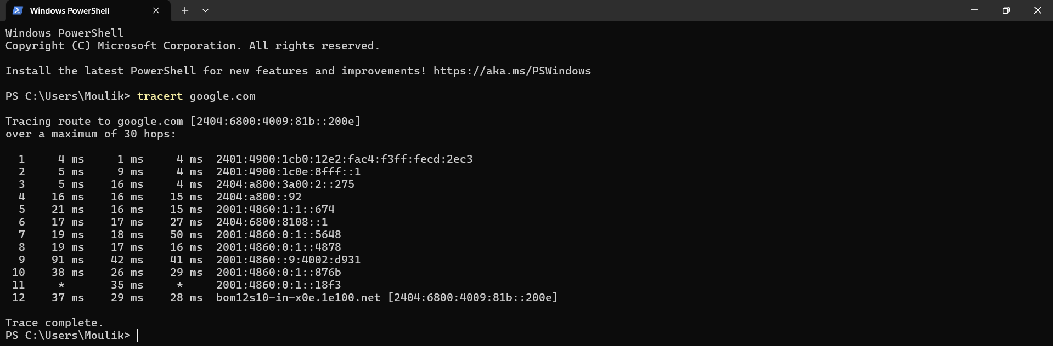

**The below shows the IP addresses inn IPv4 format:**

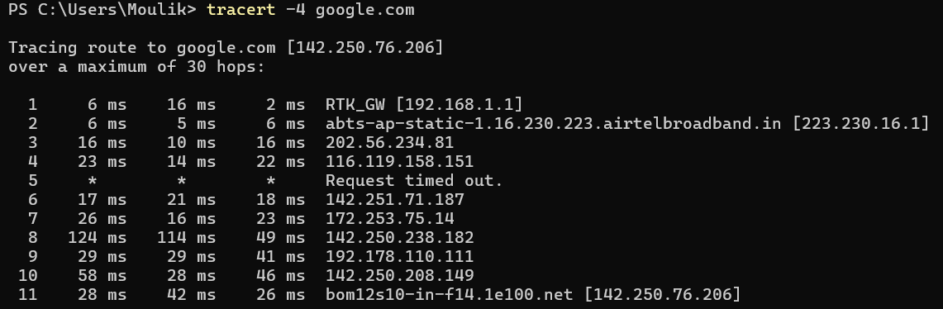

**We can also set the maximum number of hops before the packet reaches the final destination. IPv6 and IPv4 format.**

